Strategy Game Mechanics

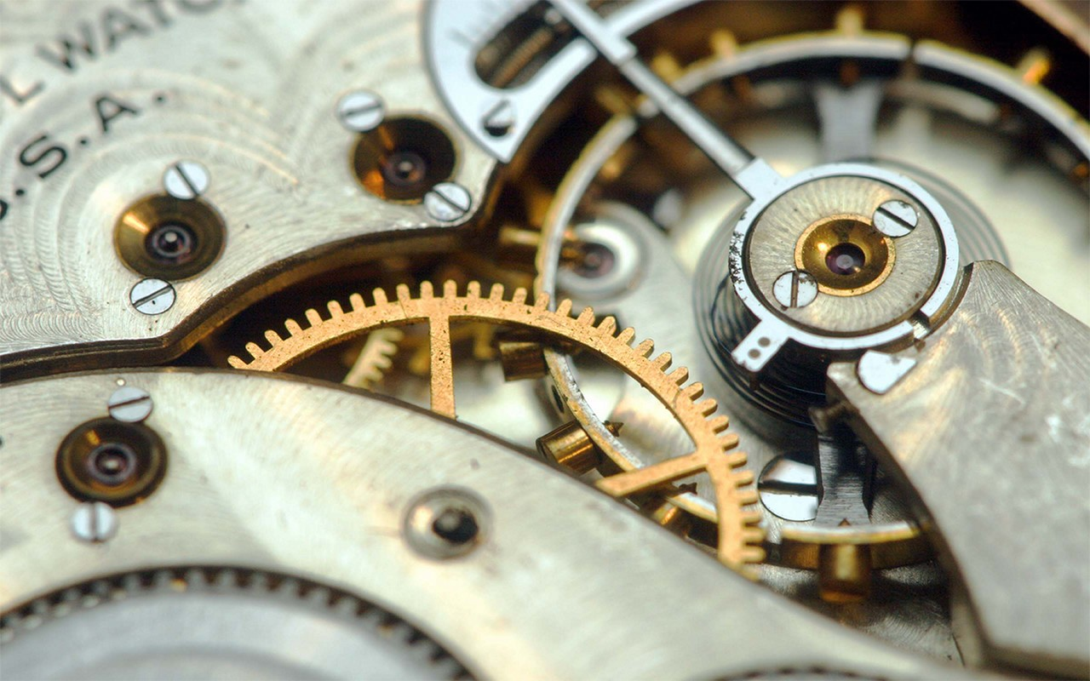

In a board game, mechanics are the (mostly physical) actions a player undertakes in order to play a game. As a game designer, these are your tools to create experiences for players where they get to make decisions as they play.

Your instructions:

- Choose a practice theme (fantasy, the tooth fairy, or piranhas) and brainstorm how each mechanic can fit that theme.
- Draw a symbol or write a keyword in the space provided to help you remember that mechanic.
- Write a one sentence description of how each specific mechanic can be applied to your theme.
  - The first one (Action Point Allowance) is done for you.
- There are 20 mechanics in this packet. Choose 15 of the 20 that you would like to complete.

Action point Allowance
Players’ choices are limited by a specific number of actions that can be taken on a turn. Maybe they can repeat some actions, or all actions, or maybe they can’t. Or, each action costs a certain amount, and players can “spend” however many points they have on the actions they want as long as they don’t exceed their point allowance. By scaling the point values, the most important or challenging tasks can cost more and require more planning on the part of the players to use that action. Players may gain or lose action points as they play depending on the game design. Games: Babel, Pandemic, Hey That’s My Fish!, Survive!, Dirty Birdy
Symbol or keyword | Practice Theme
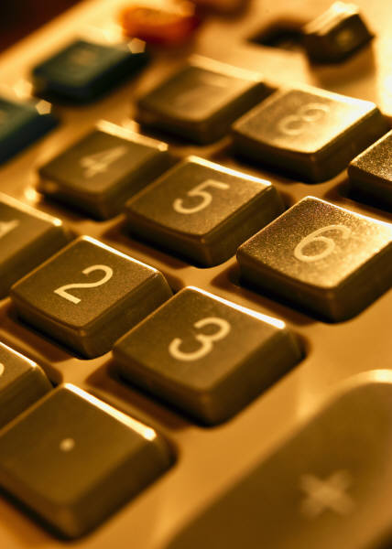 | In a fantasy theme game, players would choose the actions they want to take based on the number of points. So casting a spell could be worth 3 points, searching for objects could be one point, and attacking a monster could be 5 points.

Area Control/Influence
Players try to gain and retain control of specific, pre-existing areas on the board. Victory is determined by whomever controls the most, or most important, or some other determining factor, regions on the board. Depending on the designer’s goals, multiple players may have a presence in these regions, or regions may be held solely by one player. Regions can be strengthened, or held permanently, or change ownership depending on game play. Games: Finca, Fjords, Kahuna, Rattus, Risk, Tower of Babel
Symbol or keyword | Practice Theme

Area Enclosure
Players try to gain and retain control of sections of the board. The regions for conquest are created during the game by fence-like pieces, or some other type of bit that fulfills the task. Maybe these pieces can be moved during the game, or maybe they are fixed for the remainder. As more of the board is being claimed and closed off, the end of the game should approach accordingly. Games: Carcassone, Oasis, Go

Symbol or keyword | Practice Theme

Area Movement
Players move the pieces across the board. This movement may be based on the surrounding areas, or maybe players can move to any area they want, or maybe it’s based on terrain types, and so on. Players may have different movement abilities or may have limitations or advantages placed on them, temporarily or permanently or other. This is different than Point to Point Movement (see below) because players are not limited to following specific pathways. Games: Risk, Panic Station, Red November

Symbol or keyword | Practice Theme

Card Drafting
Players draft cards from a selection available for use during that, or later, turn. Cards may be face up or face down, or a combination. Limits on the numbers, or values, or types of cards may be placed. Players may have hand limits on how many cards they may have. Players may also be able to draw up to a maximum hand size, or players may gain or lose the maximum hand size. Players may have to draw cards in order, or may choose cards in some other fashion. Games: Alhambra, King of Tokyo, Ticket to Ride

Symbol or keyword | Practice Theme

Deduction
Players use available information to determine the solution to a puzzle, a player’s identity, or some other configuration. Designers need to figure out the types of information available to players and how that information can be obscured, revealed, and recycled so each game experience is different. Games: Loch Ness, Mr. Jack, The Resistance, Avalon, Clue

Symbol or keyword | Practice Theme
Hand Management
Players have a set of cards or tiles and must make decisions about what cards or tiles to play and when. This allows for a wide variety of choices available in a game, but only a small amount available to players per turn. Games: Alhambra, Castle Panic, Detroit Cleveland Grand Prix, Dracula, Hare and Tortoise, Kahuna, Modern Art, Surf’s Up Dude, Ticket to Ride, Tsuro, Wasabi

Symbol or keyword | Practice Theme

Modular Board
The board is not one fixed square or rectangle but is made of smaller units that can be combined in different ways which ensures that the board will be different for each game. The board can evolve as the game is played, or the board can be set up in its entirety at the beginning of the game. Games: aMAZEing Labyrinth, Dragonriders, Forbidden Island, Hey That’s My Fish!, Ricochet Robots, Survive, Tongiaki

Symbol or keyword | Practice Theme

Pick-up and Deliver
Players gather resources in specific places on the board and take them across the board to deliver them to other areas. Designers may wish to think about how many goods can be transported, if the types have different requirements, if the vessels used to transport them can be upgraded or enlarged, if resources are unlimited or finite, and if linkages between locations are pre-established or must be constructed as the game is played. Games: Empire Builder, Niagara, Flash Point, Pirate vs Pirate

Symbol or keyword | Practice Theme

Point to Point Movement
Players move their pawns across the board along specific pathways. These pathways may be fixed on the board at the outset or may develop as the game is played. These pathways may be changed as the game is played, depending on the designer’s goals. Game designers may also want to think about how many segments are optimal in a game, how many segments a player can traverse during a turn, and how many intersections and outlying segments are needed to keep it interesting. Games: HTMF, Ice Flow, Kill Dr. Lucky, Pandemic, PPG, Tongiaki

Symbol or keyword | Practice Theme
Programmed Action/Movement
Players have cards or tiles that have specific actions on them. Players choose from these tiles or cards to plan several moves at once. These cards may be revealed all at once or individually. Players may move one at a time or all at once, depending on the desired level of chaos. This mechanic can lead to a high level of player interaction due to the need to commit to choices that can easily be affected by others. Games: Duck Duck Go!, RoboRally, Jamaica, Snake Lake

Symbol or keyword | Practice Theme

Route/Network Building
Players create a network between different locations on the board using tokens, bits, crayons, or other materials. The networks may be permanent during the game or may be changed by the players or by game events. Games: Expedition, Ticket to Ride, Trans Europa, Tsuro

Symbol or keyword | Practice Theme

Secret Unit Deployment
Each player’s pawns or meeples have secret values that are not immediately visible but are revealed at specific moments, interactions, or at the end of the game. Individual players may be aware of their own pawns’ values or they may be unaware of the values. Games: Survive, Scotland Yard, Stratego

Symbol or keyword | Practice Theme

Set Collection
Players collect sets of resources or other game elements, which are then used for money, purchasing game elements, or completing some other task. Players may compete to collect the most of a set, all of a set, all of the various types available as a special set, and the items in a set may be abstract or thematic. Games: Alhambra, California, Finca, Forbidden Island, Fossil, Hare and Tortoise, Hoity Toity, Hollywood Blockbuster, Niagara, Pandemic, Save Dr. Lucky, Spy Alley, Ticket to Ride, Tower of Babel, Zooloretto

Symbol or keyword | Practice Theme
Simultaneous Action Selection
Players reveal their actions simultaneously which means players must commit to a choice and the possible ramifications if others’ choices directly interfere with theirs; therefore, bluffing may occur. Possible results include all players can take an action selected or only person can take the action. Rock Paper Scissors is a variant. Games: Apples to Apples, Labyrinth Treasure Hunt, Niagara, PPG, Shazamm!

Symbol or keyword | Practice Theme

Tile Placement
Players place tiles to create the playing space before or during the game. Tiles are usually similarly shaped, but not always. The tiles may form the game board or be place atop the game board space. Games: Alhambra Carcassonne, Dante’s Inferno, Fjords, Maori, Marrakech

Symbol or keyword | Practice Theme

Trading
Players exchange resources or other game elements amongst each other. Sometimes players may be able to trade with the game itself, although expensively. Some games simply allow players to trade, period, while others allow trading with the active player, or each player gets one chance to trade, or there are limits one the number of trades or goods traded, and so on. Games: Castle Panic, Monopoly, Pandemic

Symbol or keyword | Practice Theme

Variable Phase Order
Each round or turn is comprised of several phases and these phases may occur in a different order, or not every round, or in the order of a player’s choice, or some other method. Games: Ice Flow

Symbol or keyword | Practice Theme

Variable Player Powers
Each player has his or her own ability, skill, or additional components that add strength or weakness for each player. This asymmetrical quality can help ensure that each player does not do the same thing each turn, but care must be taken to be sure that the powers are balanced. Player powers may be established at the beginning of the game for its entirety or may change as necessary through the game. Games: Bacchus’ Banquet, Forbidden Island, Mr. Jack, Neuroshima Hex!, Pandemic, Rattus
Symbol or keyword | Practice Theme

Worker Placement
Each player has a pool of pawns or meeples and places them on specific locations on the board that provide specific actions, resources, or other benefits (turn order, scoring, and so on). If the maximum number of pawns that can be placed in an area is reached (which may be only one), then other players are prevented from placing a pawn on that space. Players may use pawns defensively to block other players from utilizing spaces as well as offensively to gain benefits. Games: Stone Age

Symbol or keyword | Practice Theme

