Strategy Game Mechanics

Name: ______________________________________________________

Period: _________________

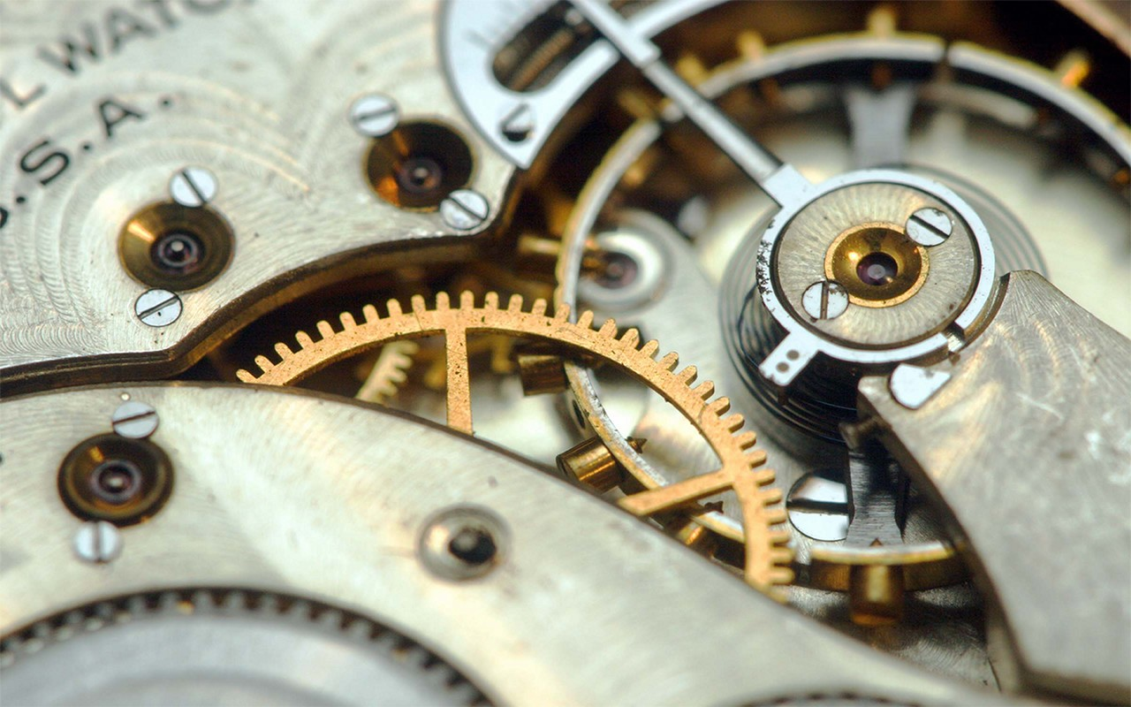

In a board game, mechanics are the (mostly physical) actions a player undertakes in order to play a game. As a game designer, these are your tools to create experiences for players where they get to make decisions as they play.

As a class, we are going to choose an practice theme and will brainstorm how each mechanic can fit that theme. For example, if the theme is the Tooth Fairy, then you would need to come up with an idea of how you could apply a mechanic like Set Collection or Area Control to the Tooth Fairy. You will also draw a symbol or write a keyword in the space provided to help you remember that mechanic.

Then, as we play games, the mechanics that you experience will become clearer to you, and you will see how the designers applied these mechanics. Perhaps specific mechanics will supply inspiration for the game you will create.

Later, you will use this packet to help you brainstorm mechanics for your own personal game’s theme.
Action point Allowance
Players’ choices are limited by a specific number of actions that can be taken on a turn. Maybe they can repeat some actions, or all actions, or maybe they can’t. Or, each action costs a certain amount, and players can “spend” however many points they have on the actions they want as long as they don’t exceed their point allowance. By scaling the point values, the most important or challenging tasks can cost more and require more planning on the part of the players to use that action. Players may gain or lose action points as they play depending on the game design. Games: Babel, Pandemic, Hey That’s My Fish!, Survive!, Dirty Birdy
Symbol or keyword | Practice Theme | How will I apply this mechanic to my theme?

Area Control/Influence
Players try to gain and retain control of specific, pre-existing areas on the board. Victory is determined by whomever controls the most, or most important, or some other determining factor, regions on the board. Depending on the designer’s goals, multiple players may have a presence in these regions, or regions may be held solely by one player. Regions can be strengthened, or held permanently, or change ownership depending on game play. Games: Finca, Fjords, Kahuna, Rattus, Risk, Tower of Babel

Symbol or keyword | Practice Theme | How will I apply this mechanic to my theme?
Area Enclosure
Players try to gain and retain control of sections of the board. The regions for conquest are created during the game by fence-like pieces, or some other type of bit that fulfills the task. Maybe these pieces can be moved during the game, or maybe they are fixed for the remainder. As more of the board is being claimed and closed off, the end of the game should approach accordingly. Games: Carcassone, Oasis, Go

Symbol or keyword | Practice Theme | How will I apply this mechanic to my theme?

Area Movement
Players move the pieces across the board. This movement may be based on the surrounding areas, or maybe players can move to any area they want, or maybe it’s based on terrain types, and so on. Players may have different movement abilities or may have limitations or advantages placed on them, temporarily or permanently or other. This is different than Point to Point Movement (see below) because players are not limited to following specific pathways. Games: Risk, Panic Station, Red November

Symbol or keyword | Practice Theme | How will I apply this mechanic to my theme?

Auction/Bidding
Players compete head to head for resources, bits, or other elements of value in the game. Whomever bids the most (most, resources, points, or some other value) often wins. Auctions can vary where bidding is secret (players commit their bids in their hand or behind a screen) or publicly. Bidding may go around and around, getting higher and higher until someone passes, or each player may bid only once. Players may pass and then join in the action later, or once they pass, they are out of that bidding round. Rather than the game designer setting prices for goods, resources, or other game elements, players do it via auction so values can reflect the players’ need for them as they play. Games: Detroit Cleveland Grand Prix, Hollywood Blockbuster, Modern Art, Oasis, Shazamm!

Symbol or keyword | Practice Theme | How will I apply this mechanic to my theme?

Betting or Wagering
Players speculate on the outcome of certain events, or a resource’s value, or some other occurrence where the outcome is immediate, or progresses during the course of the game, and they have no control over the final result. Games: Cloud 9, Igloo Pop, PPG, Renfield

Symbol or keyword | Practice Theme | How will I apply this mechanic to my theme?
Campaign or Battle Card Driven
Players have cards with specific actions written on them. These cards may have offensive or defensive qualities, or positive or negative impacts for various players, or may just have simple actions that can be taken. Players’ choices are restricted to the cards in hand, so they play cards that will strengthen their position, but may be required to play games that weaken their position if not other cards are available. This is seen foremost in war games, but may be used in other games. Games: Castle Panic, PPG, Great Brain Robbery

Symbol or keyword | Practice Theme | How will I apply this mechanic to my theme?

Card Drafting
Players draft cards from a selection available for use during that, or later, turn. Cards may be face up or face down, or a combination. Limits on the numbers, or values, or types of cards may be placed. Players may have hand limits on how many cards they may have. Players may also be able to draw up to a maximum hand size, or players may gain or lose the maximum hand size. Players may have to draw cards in order, or may choose cards in some other fashion. Games: Alhambra, King of Tokyo, Ticket to Ride

Symbol or keyword | Practice Theme | How will I apply this mechanic to my theme?
Chit Pull System
Small tokens, called chits, are pulled from a bag or face-down pile or some other fashion. These chits introduce players, abilities, obstacles, prizes, or other elements. The value and impact of these chits may vary and the combination of these chits should reflect the designer’s goals. Games: Castle Panic, Neuroshima Hex!

Symbol or keyword | Practice Theme | How will I apply this mechanic to my theme?

Cooperative Play
In coop games, players work together to beat the board. Successful coop games have a strong system so that the board is an equal, or stronger than equal, adversary. In addition, as the game is played, the board should increase in strength or difficulty. Designers should be mindful that the game is designed to prevent one player from taking control, and can think about to make the game suitable for solitaire play as well. Games: Castle Panic, Forbidden Island, Pandemic, Red November, Scotland Yard

Symbol or keyword | Practice Theme | How will I apply this mechanic to my theme?

Commodity Speculation
The value of resources change over the course of the game, and players invest in specific resources, regions, characters, or other game elements in the hope that the value of these resources will increase. Sometimes values can go down, but sometimes the value never goes down but can only increase. Games: Huzzah! Modern Art

Symbol or keyword | Practice Theme | How will I apply this mechanic to my theme?

Deduction
Players use available information to determine the solution to a puzzle, a player’s identity, or some other configuration. Designers need to figure out the types of information available to players and how that information can be obscured, revealed, and recycled so each game experience is different. Games: Loch Ness, Mr. Jack, The Resistance, Avalon, Clue

Symbol or keyword | Practice Theme | How will I apply this mechanic to my theme?

Dexterity
Players’ physical ability and skill is needed to further their position. Balancing, flicking, rolling, and other physical actions can be used in dexterity games. Games: Igloo Pop, Dirty Birdy, Stack Market

Symbol or keyword | Practice Theme | How will I apply this mechanic to my theme?

Dice Rolling
The rolling of dice, and the resulting numbers (or letters, symbols, or other) determine the outcome of specific actions, or determine the actions or choices a player has. Often used in battle, dice can be creatively applied when a fairly random element (with specific, known options) is desired. Players may have the ability to increase or decrease the value of a die roll by acquiring these abilities during the game. Games: Jamaica, Lucky Loop, King of Tokyo, Mason, Ninja vs. Ninja, Roll Through the Ages, Survive!

Symbol or keyword | Practice Theme | How will I apply this mechanic to my theme?
Hand Management
Players have a set of cards or tiles and must make decisions about what cards or tiles to play and when. This allows for a wide variety of choices available in a game, but only a small amount available to players per turn. Games: Alhambra, Castle Panic, Detroit Cleveland Grand Prix, Dracula, Hare and Tortoise, Kahuna, Modern Art, Surf’s Up Dude, Ticket to Ride, Tsuro, Wasabi

Symbol or keyword | Practice Theme | How will I apply this mechanic to my theme?

Memory
Players must utilize their memory skills to save and utilize later information about the game state as it is played. Trivia games use memory to access players’ prior knowledge (or lack thereof) in a game. Games: Codebreaker, Dracula, Magic Labyrinth, Mastermind, Snorta

Symbol or keyword | Practice Theme | How will I apply this mechanic to my theme?

Modular Board
The board is not one fixed square or rectangle but is made of smaller units that can be combined in different ways which ensures that the board will be different for each game. The board can evolve as the game is played, or the board can be set up in its entirety at the beginning of the game. Games: aMAZEing Labyrinth, Dragonriders, Forbidden Island, Hey That’s My Fish!, Ricochet Robots, Survive, Tongiaki

Symbol or keyword | Practice Theme | How will I apply this mechanic to my theme?

Paper-and-Pencil
Players record information about the game state on paper. If it is possible to avoid using this mechanic, due to the exhaustible nature of the materials, especially if it’s for a fairly simple scoring mechanic, then do so. Scoring tracks on the board, or on separate boards, can often suffice in place of paper and pencil, unless the information must remain secret for the player or the player must keep track of multiple pieces of information. Games: Roll Through the Ages, Yahtzee, Clue

Symbol or keyword | Practice Theme | How will I apply this mechanic to my theme?
Partnerships
Players work with one or two other partners against single players or other partnerships. These partnerships may be established at the beginning of the game, during the game, change throughout the game, or may simply be permanent throughout. If partnerships are used, the designer should be mindful in constructing how information or resources can be shared between the partners and to make sure that each partner has the opportunity to make choices independently from their partner. Games: Knights of Charlemagne, The Resistance, Avalon

Symbol or keyword | Practice Theme | How will I apply this mechanic to my theme?

Pattern Building
Players use game resources to construct certain patterns on the board. Often seen in abstract games. Games: Ingenious, Fits, Pente, Pentago

Symbol or keyword | Practice Theme | How will I apply this mechanic to my theme?

Pattern Recognition
As the game, players must recognize shapes or patterns that develop through the addition of game pieces. Often seen in abstract games, PR can be creatively applied to non-abstract games to give gameplay a different take on familiar subjects. Shapes can be scored accordingly to the game requirement, and it may be in players’ interest to not acknowledge some shapes to allow other shapes to evolve for greater scoring possibilities. Games: Monkey Madness, Set, Tip the Scale, Othello

Symbol or keyword | Practice Theme | How will I apply this mechanic to my theme?

Pick-up and Deliver
Players gather resources in specific places on the board and take them across the board to deliver them to other areas. Designers may wish to think about how many goods can be transported, if the types have different requirements, if the vessels used to transport them can be upgraded or enlarged, if resources are unlimited or finite, and if linkages between locations are pre-established or must be constructed as the game is played. Games: Empire Builder, Niagara, Flash Point, Pirate vs Pirate

Symbol or keyword | Practice Theme | How will I apply this mechanic to my theme?
Point to Point Movement
Players move their pawns across the board along specific pathways. These pathways may be fixed on the board at the outset or may develop as the game is played. These pathways may be changed as the game is played, depending on the designer’s goals. Game designers may also want to think about how many segments are optimal in a game, how many segments a player can traverse during a turn, and how many intersections and outlying segments are needed to keep it interesting. Games: HTMF, Ice Flow, Kill Dr. Lucky, Pandemic, PPG, Tongiaki

Symbol or keyword | Practice Theme | How will I apply this mechanic to my theme?

Press Your Luck
Players take actions during their turn and may repeat as many times as they wish. As they continue, the possible gain increases, but so does the possibility of loss of progress if an adverse condition presents itself. Often accompanied by dice because of its random nature. Games: Aquadukt, Can’t Stop, Cloud 9, Roll Through the Ages

Symbol or keyword | Practice Theme | How will I apply this mechanic to my theme?
Programmed Action/Movement
Players have cards or tiles that have specific actions on them. Players choose from these tiles or cards to plan several moves at once. These cards may be revealed all at once or individually. Players may move one at a time or all at once, depending on the desired level of chaos. This mechanic can lead to a high level of player interaction due to the need to commit to choices that can easily be affected by others. Games: Duck Duck Go!, RoboRally, Jamaica, Snake Lake

Symbol or keyword | Practice Theme | How will I apply this mechanic to my theme?

Rock Paper Scissors
Options available to players have an A, B, C nature, where A beats B, B beats C, and C beats A. A designer chooses this when he or she wants to have a circular hierarchy to determine win and loss between players. A subset of Simultaneous Action Selection (see below). Games: Hoity Toity, Stratego Legends

Symbol or keyword | Practice Theme | How will I apply this mechanic to my theme?
Roll and Move
One of the most basic mechanics and familiar to most board game players. Players roll a die to determine the number of spaces one can move or sometimes the actions that can be taken or resources gathered. The randomness of Roll and Move can be ameliorated somewhat by creating choices about the dice and how players use them. Games: Clue, Kitty Chaos, Marrakech, Ninja vs. Ninja

Symbol or keyword | Practice Theme | How will I apply this mechanic to my theme?

Route/Network Building
Players create a network between different locations on the board using tokens, bits, crayons, or other materials. The networks may be permanent during the game or may be changed by the players or by game events. Games: Expedition, Ticket to Ride, Trans Europa, Tsuro

Symbol or keyword | Practice Theme | How will I apply this mechanic to my theme?

Secret Unit Deployment
Each player’s pawns or meeples have secret values that are not immediately visible but are revealed at specific moments, interactions, or at the end of the game. Individual players may be aware of their own pawns’ values or they may be unaware of the values. Games: Survive, Scotland Yard, Stratego

Symbol or keyword | Practice Theme | How will I apply this mechanic to my theme?

Set Collection
Players collect sets of resources or other game elements, which are then used for money, purchasing game elements, or completing some other task. Players may compete to collect the most of a set, all of a set, all of the various types available as a special set, and the items in a set may be abstract or thematic. Games: Alhambra, California, Finca, Forbidden Island, Fossil, Hare and Tortoise, Hoity Toity, Hollywood Blockbuster, Niagara, Pandemic, Save Dr. Lucky, Spy Alley, Ticket to Ride, Tower of Babel, Zooloretto

Symbol or keyword | Practice Theme | How will I apply this mechanic to my theme?
Simulation
The theme is the most important aspect and the game closely models the theme as accurately as possible. Most commonly seen in war games. Games: Jamaica, Techno Witches

Symbol or keyword | Practice Theme | How will I apply this mechanic to my theme?

Simultaneous Action Selection
Players reveal their actions simultaneously which means players must commit to a choice and the possible ramifications if others’ choices directly interfere with theirs; therefore, bluffing may occur. Possible results include all players can take an action selected or only person can take the action. Rock Paper Scissors is a variant. Games: Apples to Apples, Labyrinth Treasure Hunt, Niagara, PPG, Shazamm!

Symbol or keyword | Practice Theme | How will I apply this mechanic to my theme?

Specialty Mechanic
Any sort of mechanic that is a main action taken by players that does not fit any of the above categories, but is significant enough to warrant its own category. Many game publishers are looking for innovative mechanics not seen in other games. Games: Niagara, Ice Flow

Symbol or keyword | Practice Theme | How will I apply this mechanic to my theme?

Stock Holding
Players buy, hold, and sell stocks in fictitious entities in the game. The player who owns the most of the stock reaps the greatest rewards, can exercise decision-making ability, or pay for deficits as the game requires. Games: Bull Market, Stock Exchange

Symbol or keyword | Practice Theme | How will I apply this mechanic to my theme?

Storytelling
Players tell stories, either using a printed text or of their own making. Games: Dixit, RPGs

Symbol or keyword | Practice Theme | How will I apply this mechanic to my theme?

Tile Placement
Players place tiles to create the playing space before or during the game. Tiles are usually similarly shaped, but not always. The tiles may form the game board or be place atop the game board space. Games: Alhambra Carcassonne, Dante’s Inferno, Fjords, Maori, Marrakech

Symbol or keyword | Practice Theme | How will I apply this mechanic to my theme?

Trading
Players exchange resources or other game elements amongst each other. Sometimes players may be able to trade with the game itself, although expensively. Some games simply allow players to trade, period, while others allow trading with the active player, or each player gets one chance to trade, or there are limits one the number of trades or goods traded, and so on. Games: Castle Panic, Monopoly, Pandemic

Symbol or keyword | Practice Theme | How will I apply this mechanic to my theme?

Trick-taking
When two or more players play a card or tile in a round against each other, and one person wins all cards or tiles played due to some ranking system, similar to the card game War. Games: 24 Countdown, PPG, Renfield, Tip the Scale

Symbol or keyword | Practice Theme | How will I apply this mechanic to my theme?

Variable Phase Order
Each round or turn is comprised of several phases and these phases may occur in a different order, or not every round, or in the order of a player’s choice, or some other method. Games: Ice Flow

Symbol or keyword | Practice Theme | How will I apply this mechanic to my theme?

Variable Player Powers
Each player has his or her own ability, skill, or additional components that add strength or weakness for each player. This asymmetrical quality can help ensure that each player does not do the same thing each turn, but care must be taken to be sure that the powers are balanced. Player powers may be established at the beginning of the game for its entirety or may change as necessary through the game. Games: Bacchus’ Banquet, Forbidden Island, Mr. Jack, Neuroshima Hex!, Pandemic, Rattus

Symbol or keyword | Practice Theme | How will I apply this mechanic to my theme?

Voting
Players’ votes decide the outcome of certain game events or even rules. Factors may affect the vote like resources or some other quality, but care must be taken to ensure that players don’t gang up on one person or create some other unfair inequality. Games: Lifeboats, The Resistance, Werewolf, Avalon

Symbol or keyword | Practice Theme | How will I apply this mechanic to my theme?

Worker Placement
Each player has a pool of pawns or meeples and places them on specific locations on the board that provide specific actions, resources, or other benefits (turn order, scoring, and so on). If the maximum number of pawns that can be placed in an area is reached (which may be only one), then other players are prevented from placing a pawn on that space. Players may use pawns defensively to block other players from utilizing spaces as well as offensively to gain benefits. Games: Stone Age

Symbol or keyword | Practice Theme | How will I apply this mechanic to my theme?

